CSA1110- OBJECT ORIENTED ANALYSIS & DESIGN
EXP -4 STOCK MAINTAINANCE SYSTEM

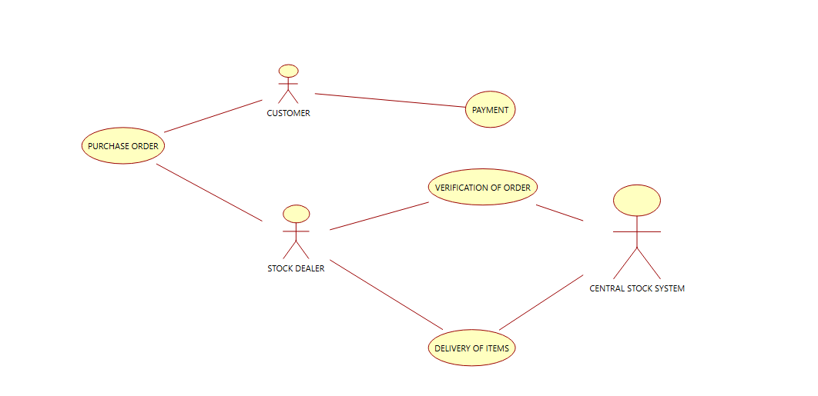

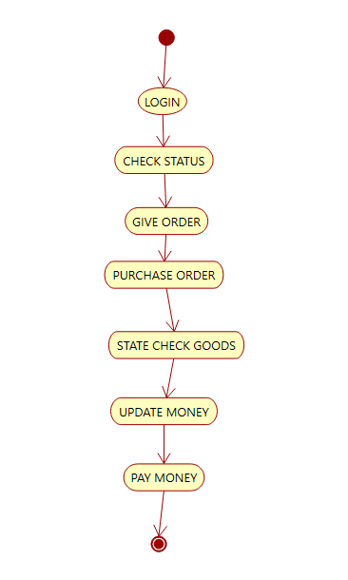

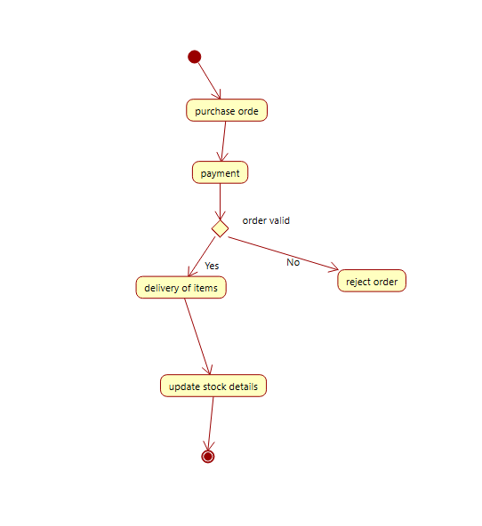
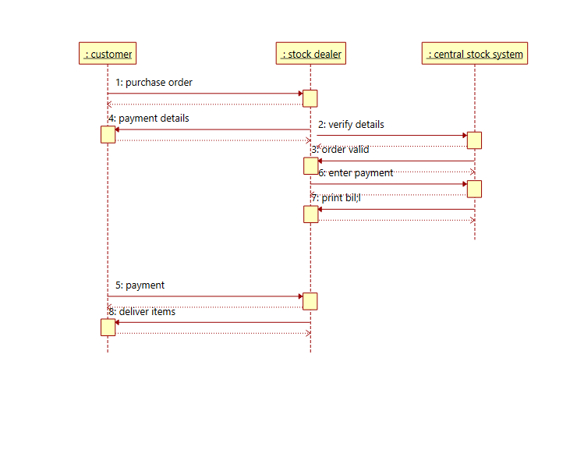

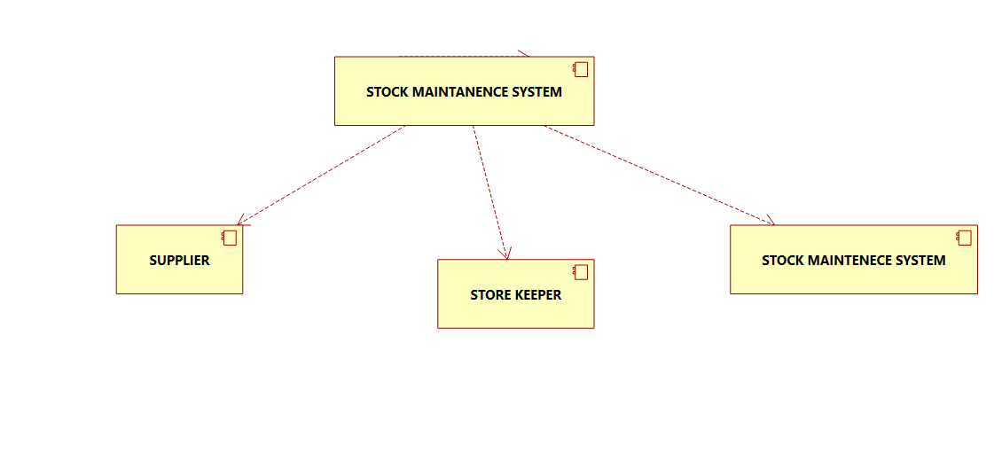

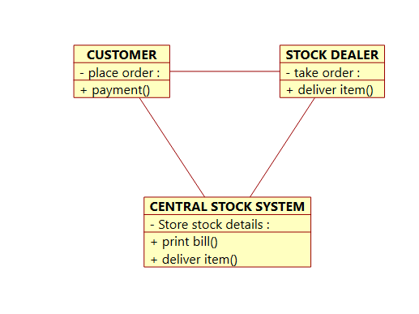
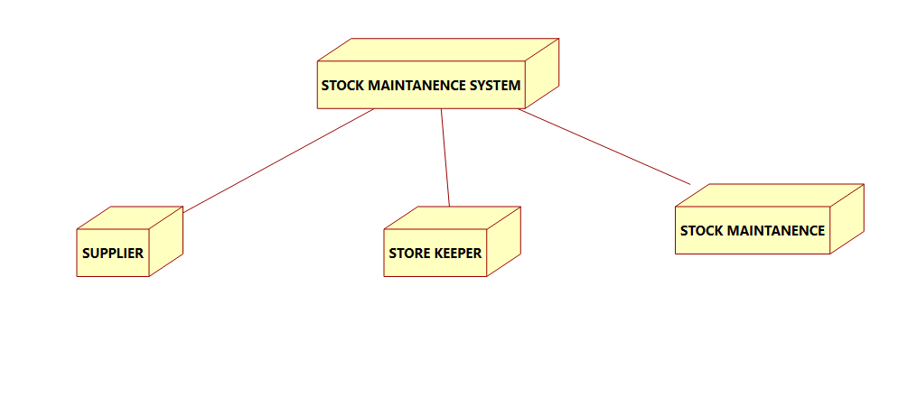

CODE

class StockMaintenance:
def __init__(self):
self.stock = {
"Laptop": 10,
"Keyboard": 25,
"Mouse": 30,
"Monitor": 12,
"Printer": 8
}

def display_stock(self):
print("Available Stock:")
for item, quantity in self.stock.items():
print(item, "- Quantity:", quantity)

def check_stock(self, item, quantity):
return item in self.stock and self.stock[item] >= quantity

def place_order(self, customer_id, item, quantity):
if self.check_stock(item, quantity):
self.stock[item] -= quantity
print("\nOrder Verified Successfully!")
print("Customer ID:", customer_id)
print("Item:", item)
print("Quantity Ordered:", quantity)
print("Items Delivered Successfully!")
print("Remaining Stock:", self.stock[item])
else:
print("Order Failed: Insufficient stock or invalid item.")

system = StockMaintenance()
system.display_stock()

customer_id = input("\nEnter Customer ID: ")
item = input("Enter Item Name: ")
quantity = int(input("Enter Quantity: "))

system.place_order(customer_id, item, quantity)
OUTPUT

